Programming 1 (Web-based Programming)

Ms. Eng

MCNDHS

Weekly Summative Assessment

|  |
| --- |
| Name: |
| Period: |

**OPEN NOTEBOOK (ONLY YOUR NOTES PLEASE)**

**Part 1 (Multiple Choice)**

1. What does this do? <a href=”http://google.com target=”_blank”>
2. Creates a file.
3. A new window for the target link.
4. A new image.
5. A folder.
6. What category does the <a href> element belong to?
7. Hyphens
8. Semantics
9. Structural
10. Frameworks
11. What is a rule for naming images in a repository?
12. Long strings of characters
13. Only Capital Words and Letters
14. No spaces
15. <br><hr>
16. What do you type if you need to include a space while naming an image inside your repository?
17. MyA spacePicture
18. my_picture
19. my-picture
20. =mypicture
21. What tag do I need to include if I want my link to open up to a new window?
22. a href= “ “ Target= “_blank”
23. alt= “ “ height= “ “ width= “ “
24. a href
25. C<sup>5</sup>H<sup>8</sup>NO<sup>4</sup>Na
26. Where is the correct location of the following code: I want some H2O
27. I want some H2O
28. I want some H<sub>2</sub>O
29. I want some <sup>H2O</sup>
30. I want some water
31. Which tag would code the following effect: I am extremely HUNGRY
32. <ins></ins>
33. <del></del>
34. <abbr title=” “>
35. <br>
36. How do I code an E-mail address?
37. <a href=” [mailto:email@google.com”> mail](mailto:email@google.com”%3e%20mail) me</a>
38. <img src= “mailto:email@google.com”> mail me
39. <br>email me</br>
40. <mail>mail me</mail>
41. How do you skip lines in HTML?
42. <p>
43. <br>
44. <img src= “ “ alt=” “ height=” “ width=” “>
45. Microsoft word 2000.
46. Which of the following is the correct formatting of a tag?
47. </p> </i>
48. <p></p>
49. (p)(/p)
50. 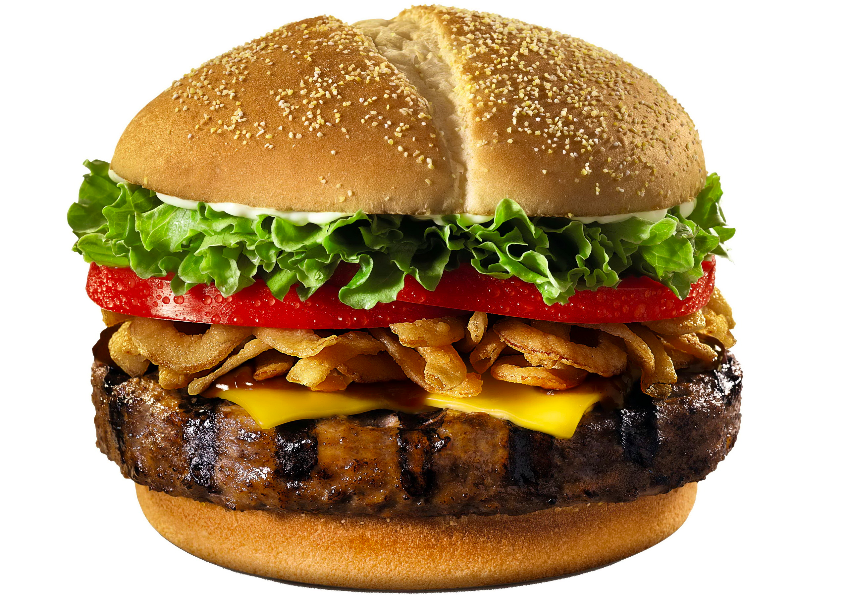(/p)(/p)
51. Which of the following is good practice for naming this picture?
52. 900cals.jpg
53. ahamburgerfrommcdonalds.jpg
54. 101615.jpg
55. burger.jpg

**Part 2: Answer the following:**

1. You were trying to create a repository for your project. The following image is what your repository looks like:

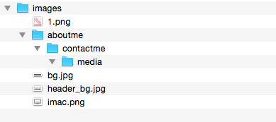

Questions:

1. You are trying to link an image from your repository to your website and typed out the following:

<img src= “images/imac.png” height=”200” width=”200”>

Nothing shows up.

Draw a diagram of how to reorganize your repository so the link will work.